Your contact partner:

Philipp Schulte-Derne
Marketing and Internet

Telephone +49 7022 702-129
Fax +49 7022 702-101
Philipp.schulte-derne@holzher.com
Total number of words: 463
Characters (not including spaces): 2921

May 2015

Date

PRESS RELEASE

Invisible Joints in Double Pack -
The Quantum Leap in Edgebanding

Our new LUMINA series offers a unique combination for processing panels: Two systems for perfectly invisible joints. The Glu Jet application system for standard use of PUR glue and the LTRONIC, the new laser edging unit from HOLZ-HER, which provides a fully integrated solution for processing laser edging. All current co-extruded and subsequently coated edging can be processed using this solution. The newly developed NIR module (NIR = Near Infrared Radiation) in the Ltronic unit is electronically controlled for activating the laser edging function layer. The result is perfect, invisible joints. With HOLZ-HER's Ltronic, users obtain a cost-effective alternative to laser and hot-air processes, ensuring perfect quality laser edging.
On the LUMINA it is possible to change over from the Ltronic to the Glu Jet unit as required within minutes using the high precision HSK interface from our CNC technology. The LUMINA has an automatic attachment recognition feature and is ready for use immediately after changing over to the Ltronic. The maximum change-over time from one type of edging to another is five minutes This change-over operation is supported by two change-over carriages designed by HOLZ-HER itself specifically for the Ltronic and the Glu Jet. These change-over carriages can be conveniently rolled up to the machine and docked on the guides. Then the HSK lock is engaged and the power supply connected using the quick-release connectors.
The advantages with the HOLZ-HER NIR module in the Ltronic laser edging unit start with its immediate availability. Ltronic does not require any unproductive heat-up times and is ready for operation at the touch of a button. LTRONIC operates without any noise emissions whatsoever and without compressed air. The wave length of our NIR module is very close to the intensity of the diode laser allowing it to optimize its energy with the utmost precision over the entire length of the workpiece. No energy is lost between workpieces.
A highlight is the edging database for laser edging completely integrated into the control on the LUMINA edgebanders. All the very latest co-extruded and subsequently coated types of edging are already stored at the factory for simple selection by the user. Each laser edging requires a specific quantity of energy, depending on factors such as edge thickness and color. After selection, the control on the LTRONIC laser edging unit automatically sets the energy as required.
On the LUMINA the Glu Jet as well as the Ltronic both have edging magazines with optimized feed angles, allowing uncompromising edging variety, stating from modern high gloss edging to thick edging cross sections in the solid wood range.

Attachments:
- Lumina edgebanders
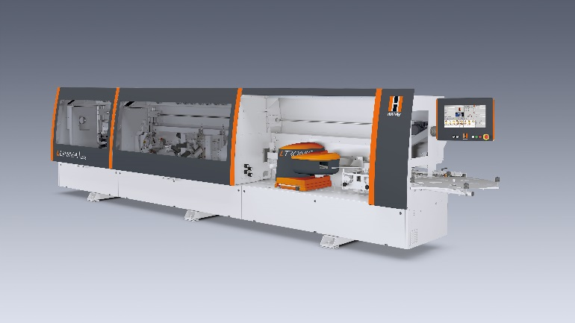
- Ltronic and Glu Jet change-over station with setup carriage
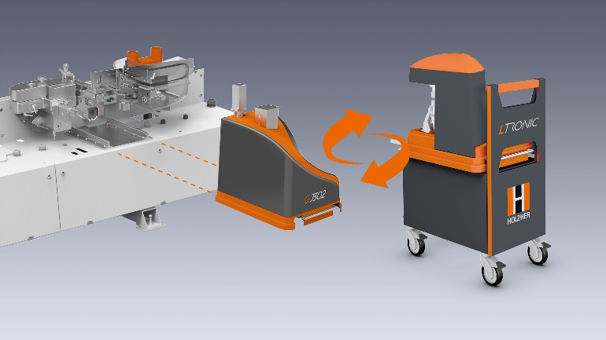
- Laser edging database.
