Your press contact:

Philipp Schulte-Derne
Marketing and Internet

Telephone +49 7022 702-129
Fax +49 7022 702-101
Philipp.schulte-derne@holzher.com
Words in total: 390
Character (with space character): 2494

May 2015

Datum

Press Release

The (r)EVOLUTION continues - The vertical CNC series from HOLZ-HER is now being supplemented with two new models.

The successful EVOLUTION series from HOLZ-HER will be supplemented by two additional models for the LIGN 2015.
The EVOLUTION 7401 is a pure-bred vertical drilling center with ideal price/benefit ratio, with standard drilling head already equipped with 9 vertical and 6 horizontal drill chucks, as well as a grooving saw. For extreme flexibility an optional XL drilling head is also available, with up to 22 drilling spindles and grooving saw.
Customers who need a cutter unit for formatting, cutouts and pockets, are also well served with the EVOLUTION 7402. In addition to its powerful 5.6 kW spindle, this cutting and drilling center is also available with the drilling head versions mentioned above.
The new members of the EVOLUTION family adapt themselves fully automatically to material thicknesses from 8 to 70 mm without any setup work whatsoever. Generous machining dimensions from 2,500 mm in the X direction without additional panel support as well as 920 mm in the Y direction are a further advantage of the "little" EVOLUTION 7401/7402. In addition, the new vertical HOLZ-HER CNC units come with an exceptionally small space requirement. Naturally a laser measuring feature is available for determining the precise length of workpieces. The proven vacuum clamping system on the EVOLUTION series has been adapted to the two new models for holding highly differing types of material securely and gently.
The machining capabilities and versatility of the EVOLUTION are enormous. In addition to production of furniture components and counter tops using panels or solid wood, cutting and drilling processes on workpieces with complex shapes will be demonstrated at the LIGNA. An absolute highlight at the LIGNA will also be a live demonstration of light-reflex engraving: For this purpose HOLZ-HER will be introducing the unique, patented Pic2Plate software allowing image data to be copied and vector cutting programs to be generated quickly and easily.
Naturally the EVOLUTION 7401 and 7402 are equipped with the latest version of CAMPUS/NCHops.

Attachments:
- EVOLUTION 7402 from HOLZ-HER – high quality equipment with drilling head and cutting spindle
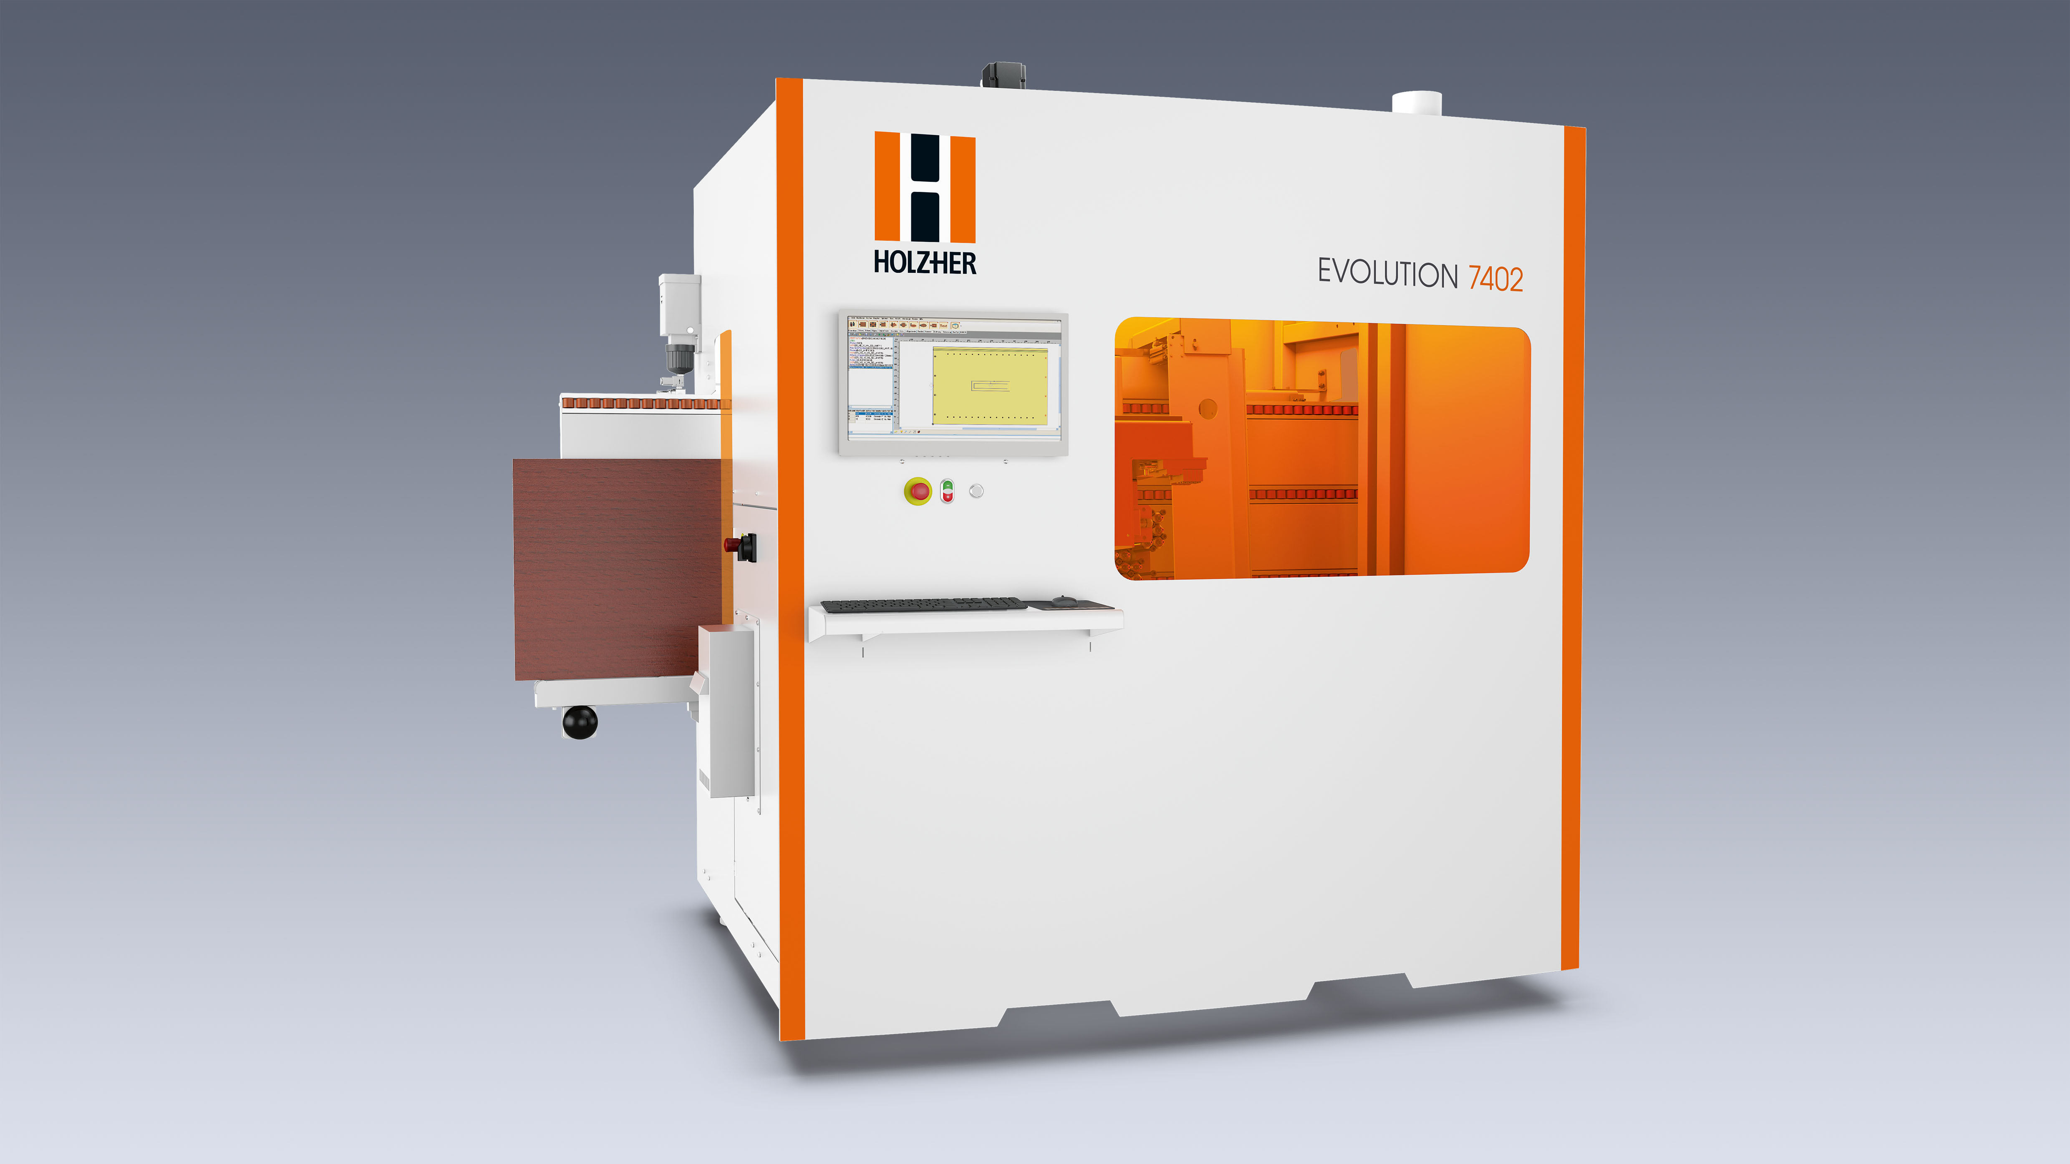

- Standard and XL drilling head
Fully equipped with 16 drillsand grooving saw as standard feature, also available with optional XL drilling head with up to 22 drilling spindles and grooving saw.
